Web Services decouples business from Front End.
The Client doesn’t have to know how server works and server doesn’t have to know about client.
Each side (Client and Server) does what it does well.
Traditionally before Web Service, Jar files were used to access service from 1 system to another. Then RPC which works like RMI, then Web Service evolved.

Server (web service) can be developed from Node.js, J2EE or any.

SOAP is old, REST is new.

Why Web Service:
Need to access the application functionality in a simple manner, just by passing the input in xml.
EX: Add 10, 20 in the form of XML.
Advantage
Service can be accessed independently across application and languages.
2 types of WebServices are available
1) Big Web Services.
2) REST (REpresentational State Transfer) Web Services
REST in short
There is no "official" standard for RESTful web service.
It is based on the concept of "representations" of "resources".
Ex: http://localhost/Clients
http://localhost/Client/1
http://localhost/Client with XML body <name>Prabhu<age>28
WADL(Web Application Description Language) is used instead of WSDL.
Big WebServices

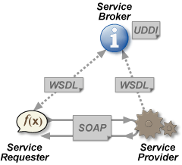
There are 4 major components within the web service architecture:
Service Provider:
This is the provider of the web service. The service provider implements the service and makes it available on the public.
Service Requester:
This is any consumer of the web service. The requestor utilizes an existing web service by opening a network connection and sending an XML request.
Service Registry and Discovery (UDDI):
This is a logically centralized directory of services. The registry provides a central place where developers can publish new services or find existing ones.
Service description
This layer is responsible for describing the public interface to a specific web service. Currently, service description is handled via the Web Service Description Language (WSDL).
Other Considerations while implementing WebService:
Service Transport:
This layer is responsible for transporting messages between applications. Currently, this layer includes hypertext transfer protocol (HTTP), Simple Mail Transfer Protocol (SMTP), file transfer protocol (FTP), and newer protocols, such as Blocks Extensible Exchange Protocol (BEEP).
XML Messaging:
This layer is responsible for encoding messages in a common XML format so that messages can be understood at either end. Currently, this layer includes XML-RPC and SOAP.
XML-RPC
It's remote procedure calling using HTTP as the transport and XML as the encoding.

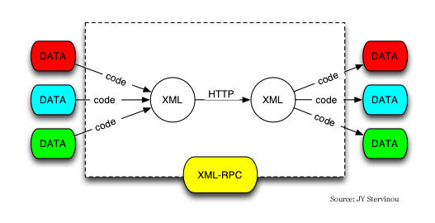
SOAP
It is an XML based protocol that consists of three parts:
1) envelope that defines a framework for describing what is in a message and how to process it,
2) Encoding Technique(data type)
3) Transport type (normally HTTP)

RPC- java to java
XML-RPC- any to any

Few Words about Service Transport
The bottom of the web service protocol stack is service transport. This layer is responsible for actually transporting XML messages between two computers.
- Hyper Text Transfer Protocol (HTTP)
- Currently, HTTP is the most popular option for service transport. HTTP is simple, stable, and widely deployed. Furthermore, most firewalls allow HTTP traffic. This allows XMLRPC or SOAP messages to masquerade as HTTP messages. This is good if you want to easily integrate remote applications, but it does raise a number of security concerns.
- Blocks Extensible Exchange Protocol (BEPP)
- One promising alternative to HTTP is the Blocks Extensible Exchange Protocol (BEEP).BEEP is a new IETF framework of best practices for building new protocols. BEEP is layered directly on TCP and includes a number of built-in features, including an initial handshake protocol, authentication, security, and error handling. Using BEEP, one can create new protocols for a variety of applications, including instant messaging, file transfer, content syndication, and network management
SOAP is not tied to any specific transport protocol. In fact, you can use SOAP via HTTP, SMTP, or FTP. One promising idea is therefore to use SOAP over BEEP.

